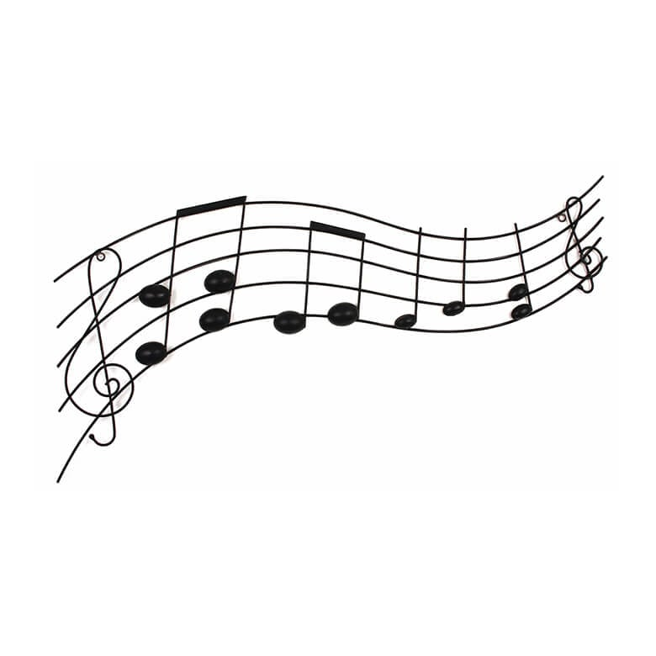

Reading Haydn Choir 100 Club

Our **100 CLUB** is a simple, voluntary and close-to-painless way to support the choir, with the opportunity to win a cash prize three times a year. Anybody over 16 years of age can become a member of the 100 Club. It is not restricted to members of the choir and you are encouraged to get family and friends to join. The club runs for 12 months beginning on 1st May 2025 and ending with the final draw in April 2026.

**How it works**:

* Each 100 club member signs up **for a full year** and pays £1/week in quarterly payments of £13 made by standing order or a single annual payment of £52.
* Signed up members are allocated a number, according to the order in which applications are received and processed.
* Each term, all the numbers are put in a hat and two prize winners are drawn. Each winner will receive one of two equal cash prizes.

**How much could you win?**

The amount of prize money is determined by the number of people who sign up. For example, if we have 30 members, our total takings for a year are £1560. Half of this, £780, is earmarked for choir funds, leaving a further £780 to be divided between six prize winners over the year, making each prize £130. So in return for boosting choir funds, at each draw you will have a chance of recouping your year’s club contribution in full plus a tidy bonus.

We are hoping that many of you will sign up to join our 100 Club before 30th April 2025.

**How to join**:

1. Set up a standing order to pay £13 each quarter into the new 100 Club bank account. The payments should be sent 1st May, 1st August, 1st November 2025 and 1st February 2026 with the reference “100 club[your name]” . The 100 Club account details are:

Account name: Reading Haydn Choir, Sort code: 30-96-96, Account no: 87527168.

Please note that this is a **new account** for the 100 Club: please don’t use any other Reading Haydn Choir account details you may already have.

1. Return the application form to **Carol Scleparis.** Details on the application form.
2. On receipt of your application you will be allocated a membership number. Then all you have to do is sit back and wait.
3. Draws will take place at the end of each term.
4. If you can’t set up a standing order, we can accept card/cheque payments on or about the dates shown in point 1 of this list. Please tick the appropriate box on your application form to indicate the method of payment. You can also pay annually by bank transfer, card or cheque in May 2025.

**Please note that you need to be willing to commit to membership for a full year to ensure that your name is included in each draw. You cannot join once the club year has started, so**

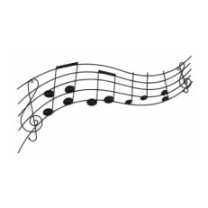**… hurry hurry hurry**! The closing date for membership of this year’s club is 30th April 2025.

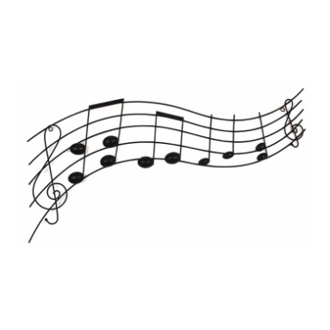

**Guidelines and Rules of The Reading Haydn Choir 100 Club Lottery**

1. Reading Haydn Choir 100 Club is registered as a Small Society Lottery with Reading Borough Council in accordance with the Gambling Act 2005.

2. There shall be one prize draw per term with two winners each draw. This gives a total of three draws and six winners.

3. Entry into the draw can only be made by completing an entry form and making payments annually or quarterly by bank transfer, cheque or cash.

4. Entry into the 100 Club costs £13 per quarter which makes a total of £52 per year. Each member opting to subscribe into the Club must subscribe for a full year commencing 1st May and will be assigned a unique number. At the end of that year, the member can terminate their membership or subscribe for the ensuing full year (and thereby continue their membership under the same unique number). You will receive confirmation of the number issued to you and the draws into which you have subscribed.

5. Anybody over 16 years of age can become a member of the 100 Club. It is not restricted to choir members only and you are encouraged to get family and friends to join.

6. A member is eligible for inclusion in the draw so long as the subscription has been paid.

7. At no time shall a member with a current subscription be permitted to make, or purport to make, a second subscription; any monies remitted to the choir in breach of this stipulation will be returned to the member as soon as reasonably possible.

8. Unless otherwise agreed, a member will be deemed to have left the 100 Club if his or her renewal of subscription remains unpaid for a period of three months.

9. The draw will take place within the premises of St Joseph’s College in the presence of a minimum of three people including at least one Reading Haydn Choir committee member.

10. The decision of the Reading Haydn Choir committee shall be final in all matters requiring adjudication.

11. The Reading Haydn Choir committee shall have the power to amend or revoke these rules at their absolute discretion with such reasonable notice to the 100 Club members as necessary.

12. Draw results will be emailed to members and displayed on the Reading Haydn Choir website. Winners will be notified individually.

13. Prizes will be awarded according to membership of the 100 Club for that year as follows:

* There will be a total of 3 draws per year.
* 50% of the net payments will make up the Prize Fund.
* One third of the annual Prize Fund will be paid out after each draw.
* There will be two prize winners each draw.
* Each prize winner will receive exactly half of that term’s prize money.
* The remaining 50% of the term’s net payments will be allocated to Reading Haydn Choir.
* Only one prize can be won per number per draw.

14. The 100 Club administrator will aim to pay prizes to the winners within a reasonable period after each draw.

15. Payment of prize money will be made by bank transfer or cheque in accordance with winner preference.

16. The 100 Club administrator is Carol Scleparis.

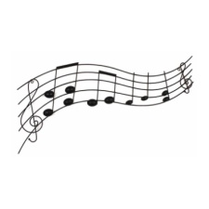17. Reading Haydn Choir 100 Club will collect your name, address and contact details to maintain your subscription and to ensure that you receive any prize monies due to you. We will not share your information with any other parties, except your name in the event that you should win (see 12 above).

Registered Charity No. 282451

Gambling Licence No: LLR000270