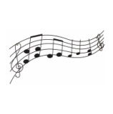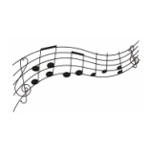Reading Haydn Choir 100 Club

Application Form

|  |  |  |  |
| --- | --- | --- | --- |
| |  |  | | --- | --- | | Name |  | |  |
| Email address  Address  **Please tick one option:**   |  |  | | --- | --- | | ☐ | I confirm that I have set up a quarterly standing order to pay £13 by 1st May, 1st August, 1st November 2025 and 1st February 2026 | | ☐ | I will pay £13 by 1st May, 1st August, 1st November 2025 and 1st February 2026, by cheque | | ☐ | I will make a single payment of £52 before 1st May 2025 by bank transfer or cheque | |  |
| |  |  |  | | --- | --- | --- | | **Bank details:** |  |  | | Account name: | Reading Haydn Choir | *Note that this is a separate 100 Club account.* | | Sort code: | 30-96-96 | *Please do not use any other* | | Account number: | 87527168 | *Reading Haydn Choir bank details you may already have.* |  |  |  | | --- | --- | |  | I confirm that I am over 16 years of age and that I have read and understood the Reading Haydn Choir 100 Club Rules and Regulations as set out in the Guidelines and Rules document. | |  |
| |  |  | | --- | --- | | Signed |  | | Date |  |   Please return this form to Carol Scleparis the 100 Club Administrator either by hand,  by email to [rdghaydnchoir@gmail.com](mailto:rdghaydnchoir@gmail.com)  or post to The 100 Club, 8 Devonshire Park, Reading, RG2 7DX |  |
|  |  |